Branding Guidelines for Those Who Receive Allocations
Dear Community Partner,
In order to continue funding valuable programs like yours, we need your help in letting people know that these programs are made possible through the Federation and Foundation. The Jewish Federation of Western Massachusetts and The Jewish Endowment Foundation are able to fund these programs through generosity of the community. Therefore, it is essential that the community is aware of our sponsorship, and our ability to help people secure their legacy through charitable giving.
As a condition of receiving an allocation from The Jewish Federation of Western Massachusetts, we expect that an acknowledgement of the allocation will be included in all marketing, communications, and program materials that reference the funded program(s). These materials include (but are not limited to) program handouts, flyers, postcards, newsletters, reports, and press or media releases.
If no marketing or communications materials are associated with the funded program, we ask that you take steps to inform your constituents of the allocation.

For Print or Digital Program Materials
In any print or digital publication where it is possible to include a logo, we have provided a variety of logos for you to download at jewishwesternmass.org/logos
If you are not specifically recognizing the Federation and the Foundation in your text, use one of the logos that includes the words “Sponsored by,” or “Made possible by”
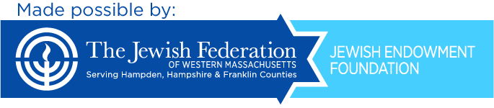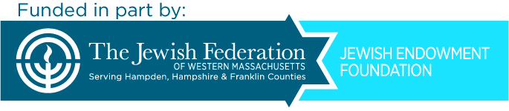

For Press Release
In press releases or other publications where applicable, the following language should be used to describe the Jewish Federation of Western Massachusetts:
The Jewish Federation of Western Massachusetts ensures the continuity and well-being of a vibrant Jewish community in the Pioneer Valley, Israel, and the world.
Thank you very much for helping us continue the work of the Federation and Foundation.

